# Sniffs of Failure: Discomfort, Unease and Serendipity in Sensory Communication Design

### Kate McLean

## Introduction

In 2018 I was I was invited to run an event to demonstrate the potential of smell in storytelling. I proposed a series of participant smellwalks, and subsequent mapping, to encourage the inclusion of smells in the stories we tell and share. My design-led practice of smellscape mapping requests participants to work through their own fear of failure in their capacity to detect and describe smells. Retrospectively I can count numerous points of failure and will highlight three that stand out in this chapter: i) failure to be able to smell (anosmia), ii) failure to record meaning associated with participant-drawn symbols (researcher oversight), and a iii) serendipitous failure in weather (rain). I will also allude to some advantages of regarding failure as an integral part of the design process. My specialist field, sensory communication design, is nascent[1]. My research into communication of olfactory perception using a range of visualization techniques and mappings has been queried and challenged since ‘Smellmap Edinburgh’ exhibited in at the *International Edinburgh Science Festival* in 2011.[2] While the history of mapping smells dates to the 1700s to track trajectories of disease and industrial emissions, there remains an overarching critique of representing smells due to their ephemerality.[3]

From this perspective there are more reasons to not map smells than there are to do so: smells cannot be seen and therefore cannot be verified; smells are subjective and cannot be validated; smells are ephemeral and cannot be pinpointed; smells do not have defined area of existence or static boundaries; smells do not exist — except as collections of airborne molecules — until humans differentiate them; physiological processes such as habituation and adaptation[4] affect human capacity to detect smells; humans are inconsistent at identifying smells.

Despite the series of objections, there is precedent for mapping smells in place from fields such as odor monitoring, public health, and olfactory art dating back to the 1700s in Europe and the USA.[5] Interestingly, historical smell maps point to failures of urban industrial planning to take account of odors in factories as the highlight sites where the emissions impact. Recent creative approaches to sensory communication design embrace and collate numerous variables to engage meaningful dialogue about smells, and the human capacity to detect, differentiate, and describe them.

## Failure in Design

While dictionary definitions of failure posit it as the opposite of success — anywhere on a sliding scale between a flop and a disaster, pertaining to both quantity and quality — failure is integral to the design process. This is especially relevant to smell mapping as design that seeks to render visible a frequently overlooked and invisible to the eye sensory way of knowing. Rothbucher and Rothbucher[6] explain that prior to defining failure, it is first necessary to consider design’s function. To design something (or to actively change it) is based on a premise that the original artefact or practice is in some way lacking. Thus, failure is regarded as the initial starting point for a brief for the ‘problem solver’ designer. In smell mapping, the initial starting point is smells’ failure to be noticed, its invisibility.

In addition to failure as a starting point for design, failure is also integral to the design process whose goal according to Friedman is to ‘change existing situations into preferred ones’.[7] The design process includes scope for failure and a desire to learn from that failure; in-built is the concept of ‘iteration’,[8] in which multiple versions of a design can be tested and compared with each other prior to selecting and re-developing a final optimal version. Smell mapping, as a nascent field, undergoes methodological changes and design decision-making in every new smell mapping project as each site, participant group, and project outcome differs and requires constant, rapid iteration. From a digital perspective, the Interaction Design Foundation (an educational network advocating user experience (UX) design) suggests design failures are ‘solutions that are outlandish or impractical’; with three potential points of failure: i) user interface design, ii) information architecture design, and iii) adoption/acceptance by the target audience.[9]

The godfather of UX Don Norman writes how ‘we need to remove the word failure from our vocabulary, replacing it with learning experience. To fail is to learn: we learn more from our failures than our successes’.[10] The process of mapping smells connects with UX in that it has an interface (albeit non-digital) and requires adoption on the part of the target audience. In requesting participants to contribute to a map of smells, a situation of fear of failure often changes into a new one of self-belief (in the capacity to describe smells without specialist terminology) and advance individual knowledge (about the smells that make up everyday lives). Such an acceptance of a ‘new’ interface (the olfactory system and its subsequent processing) is achieved through clear direction and guidance. In this case, the interface has three layers: sniffing and encountering smells directly, interpreting smells into language descriptions, and translating the descriptions into visual symbols that have both color and form. It requires courage to set aside insecurities and sniff potentially disgusting objects and places. Participants frequently worry that they might fail to smell anything at all. To mitigate this, every smellwalk is scaffolded by encouraging olfactory success by sharing smell encounters at regular 15-minute intervals. This reduces the fear of failure as participants become confident in their detection and description capabilities and feel empowered to sniff closer to new objects.

On a positive note, smell communication has no rule book, and rarely does Western schooling teach either descriptive or visual vocabularies. We have extremely limited prior reference for the representation of smell in either color or shape. And, as Kessler suggests, ‘If you don’t know the rules, you don’t know not to break them’.[11] Without prior art and rules, smellwalkers are liberated to do as they please, although I have noted on some occasions that a lack of prior art can equally paralyse some participants.

## Making Meaning Through Storytelling

The questions as to how storytelling might be augmented for future generations was tackled annually (prior to 2019) by a festival known as the Future of Storytelling (FoST).[12] Over three days in September 2017, this took place at Snug Harbor on Staten Island, New York.[13] FoST’s goal is to change the way stories are told using immersive, interactive, and cutting-edge technological approaches. Most of the commissioned events blend digital and physical worlds; mansion rooms are given over to virtual reality experiences, in the 83-acre park marquees contain mixed reality experiences blending hologram and human interaction, the gardens host theatrical performances in which a foam-filled bathtub is the stage. FoST invites attendees to discover a range of dissemination practices; in a digital age oral traditions can be augmented by both technologies and the under-used senses. While the story might be timeless, the method of delivery alters.

## Failure to Smell

To collect data for the smell map, FoST created a sign-up list of participants for seven smellwalks over three days with a maximum of 15 people per walk. A smellwalk is a sensewalk[14] during which the primary mode of information encountered is deliberately switched from visual to olfactory and comprises of three sections with strategies for sniffing and recording the odors encountered; smell-catching, smell-hunting (see Figure 20.1), and free-smelling.[15] In each section, participants are asked to record up to four smells. A group discussion punctuates each section, encouraging the sharing of smells and conversation about similar encounters, smell associations, general queries, and a chance to unpack the new experience.

Common concerns and questions at the start of every smellwalk focus on individual inability to smell (having a poor sense of smell) and not being able to name smells correctly. Human olfactory dysfunction is assessed to affect 3-22% of the population,[16] with a range of dysfunction from complete inability to smell to slight impairment. The aging process has an impact on smell detection,[17] which means I scan each smellwalk group carefully and note who might need greater encouragement. Concerns over potential failure to identify smells, which in the Western world is poor compared to other cultures and languages,[18] I allay by explaining the purpose of the walk is to ‘name’ smells, rather than ‘identify’ them, and give examples from previous smell names such as the ‘shattered dreams’[19] and ‘a hard life’[20] from previous projects. Smell naming through description removes failure, drawing instead on participants’ lived experience.

During one of the FoST smellwalks, a participant stopped during the smell-hunting (second) section of the walk, and when I enquired as to why, he replied that he was devastated to discover that his sense of smell was almost non-existent and that he needed to process what this meant to him. Anosmia, ‘the absence of a sense of smell’,[21] is rare. In 2017 just 3% of Americans had either no sense of smell or an extremely limited sense of smell.[22] Prior to the COVID-19 pandemic, smell loss was most often seen as an indicator of aging, or as an early warning for neurogenerative conditions such as Parkinson’s and Alzheimer’s disease,[23] or an unfortunate result of an accident or infection. The effects of such a discovery during a pleasurable weekend meant that the participant decided it would be better for him to step away from the activity, seek medical advice after the weekend, and contact specialist smell disorder support groups Fifth Sense and AbScent[24] for further information. The experience brought the ethics of the smellwalk to the fore and the requirement for great sensitivity in responding to physical participation in the creation of new work. A failure to be able to smell has repercussions for inclusivity and equality of experience in smell mapping projects. In 2015 Fifth Sense conference attendees participated in a smellwalk and were paired with ‘smell buddies’ who described the aromas encountered.

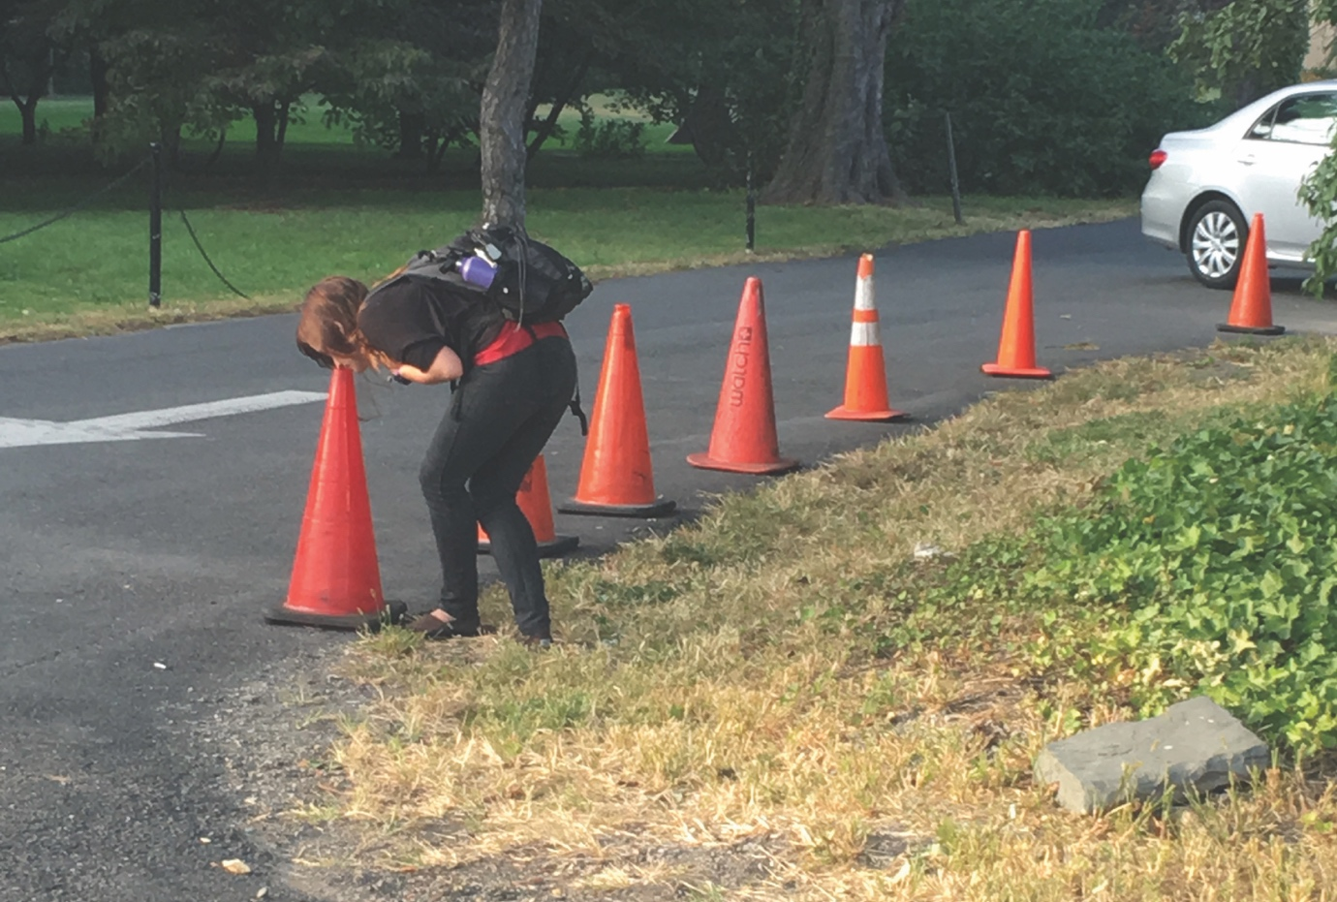

Figure 20.1: Smellwalk participant engaged in smell hunting (smelling objects in close proximity based on other sensory stimuli, in this case the bright orange color), 2017. Photo credit: Kate McLean

## Failure to Record

My concept for the smellmap was ‘ephemerality’, to match the fleeting nature of smell perception and the limited time span. I created a three-metre square base map of the site of Snug Harbor on Staten Island on the tarmac in the grounds using wax crayons from a gridded plan to indicate the roads, buildings, and the ocean (see Figure 20.2).

Figure 20.2: Gridded plot of the Snug Harbor site for either direct use indoors or transfer to outdoors, 2017. Photo credit: Kate McLean

The smellwalk participants were invited to the ‘crayon ground map’ and given an opportunity to collaborate/co-create and select from a choice of colored chalk crayons to communicate a single geolocated smell from their smellwalk. In addition to enabling the participants to consider how to communicate their smell experience visually, the reaction to the symbols were intriguing to me as a researcher. Without any precedent of a visual language for smell, a freedom in the audience responses veered in two directions; for some there was a freedom to draw anything, for others there was a paralysis. As the map filled with symbols the participants had a chance to see previous examples and could respond accordingly. The visual symbols largely represented the source of the smell; bathroom, watermelon, books, boxing gloves (see Figure 20.3), meat, an insect, a section of rope, the schoolhouse. Some participants, however, failed to record their smells. The failure to record lessened as time went on, and the stories associated with the graphics prompted imaginative leaps to enable visualization of smells as individual experiences.

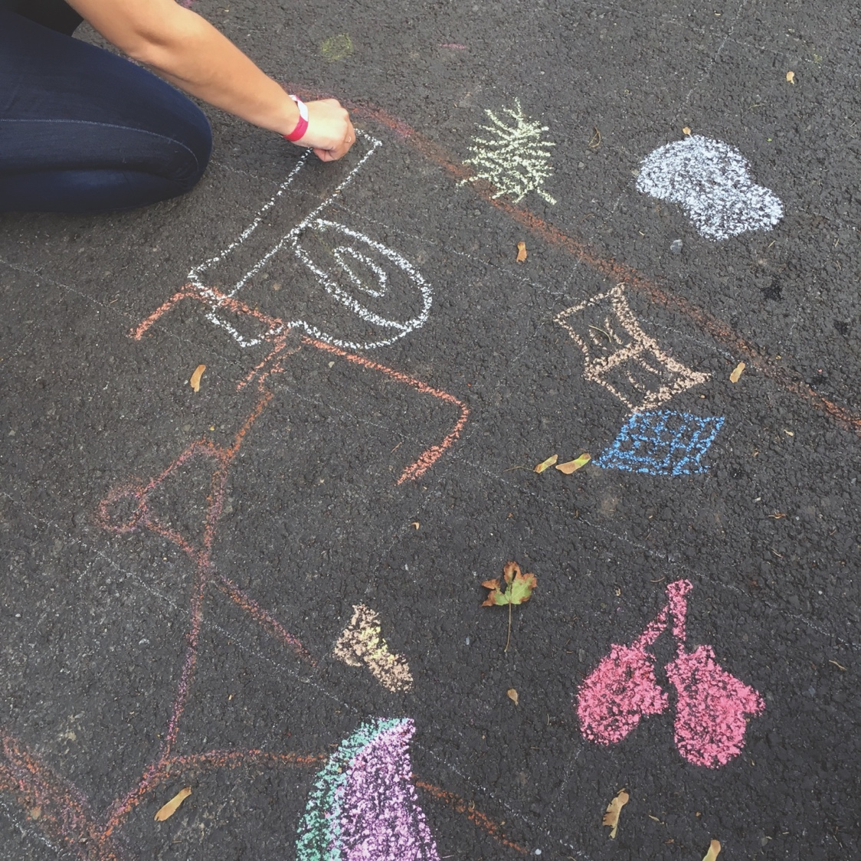

Figure 20.3: Visualization of literal smell sources; bathroom, watermelon, books, boxing gloves, 2017. Photo credit: Kate McLean.

Other visuals represented a personal discover: ‘I smelled inside four bins and they all smelled different’ (see Figure 20.4). The rainbow that alludes to the range of smells encountered in a single sniff and also calls out the insufficiencies in language to describe smells adequately (see Figure 20.5). One visual, a Christmas tree, was representative of a fruit that had fallen to the ground and smelled of spices and nutmeg.

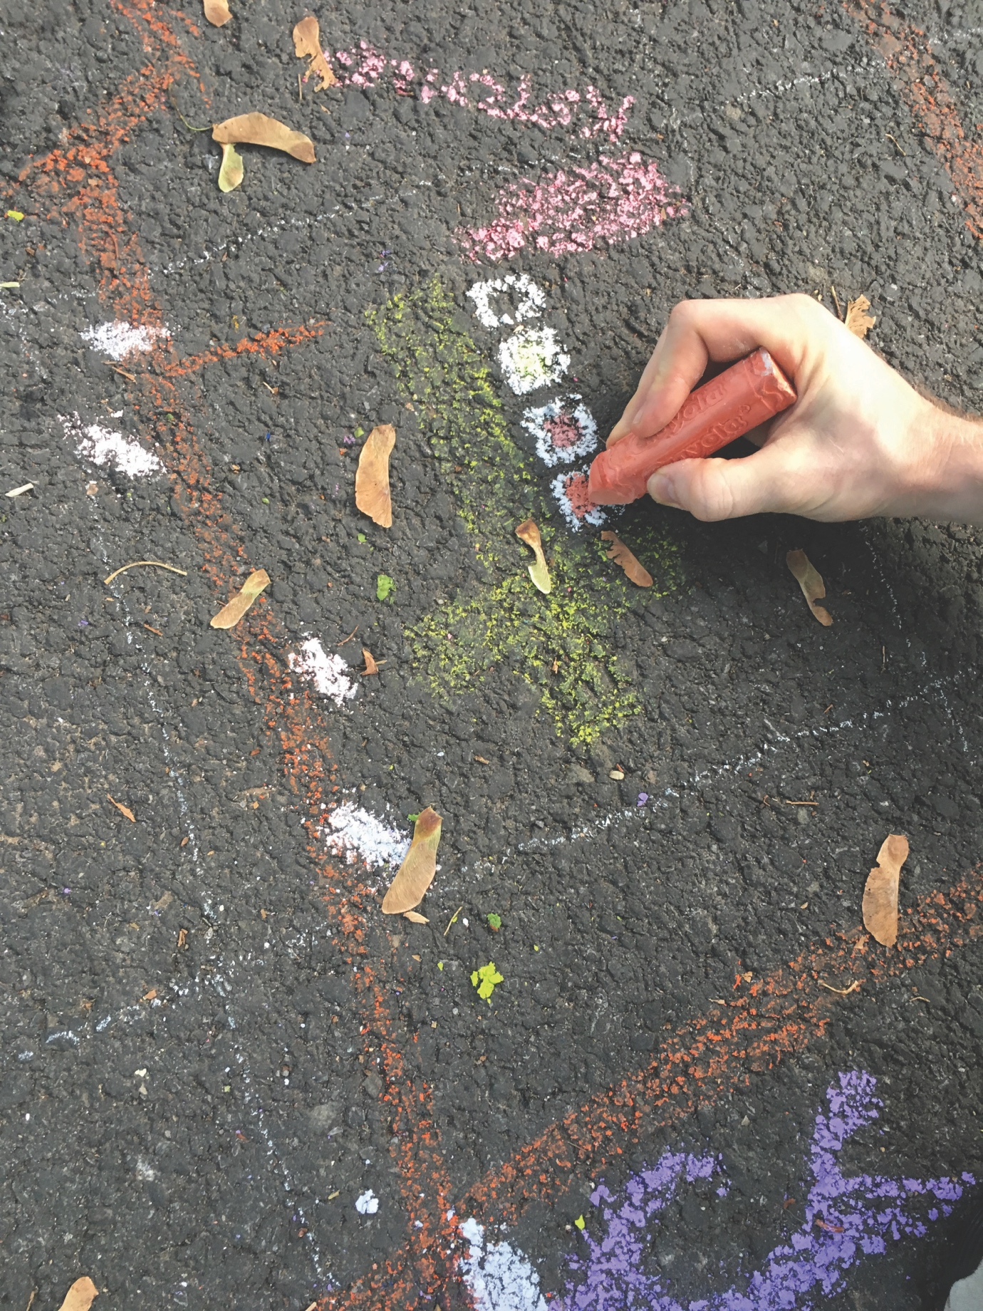

Figure 20.4: Visualization of smell discoveries: four trash cans that smelled different, 2017. Photo credit: Kate McLean.

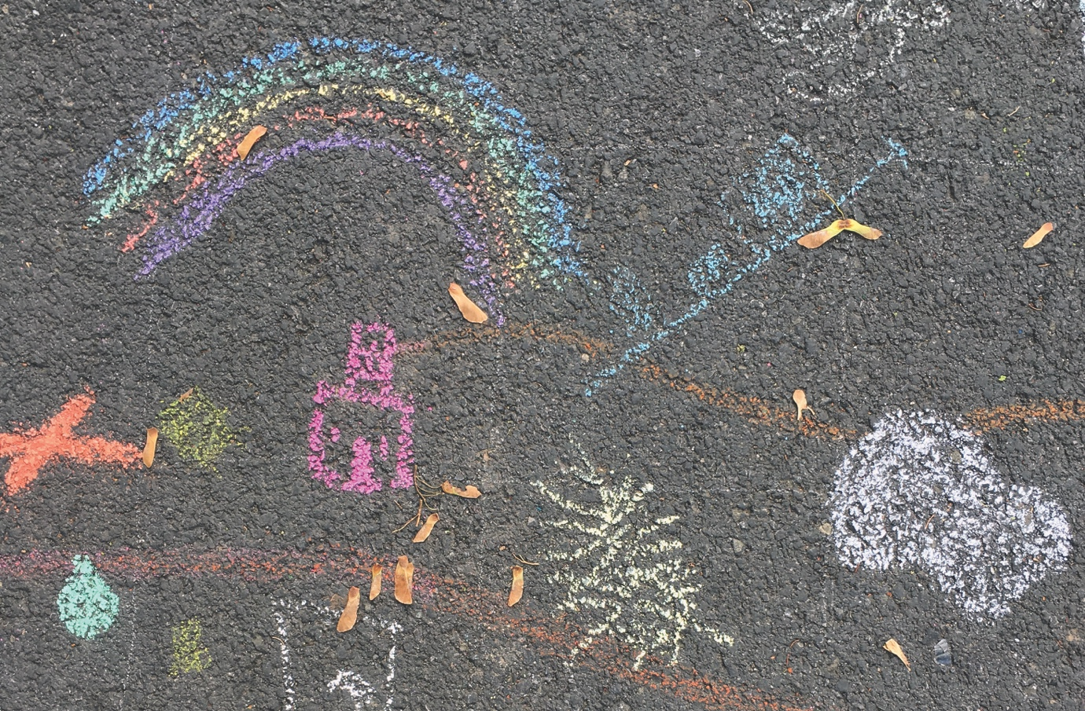

Figure 20.5: Visualization of smell discoveries: range of smells in a single sniff visualized as a rainbow, 2017. Photo credit: Kate McLean.

In total, 35 smell visuals were added to the map, but I failed to record 50% of the contributors smell graphic explanations. Reasons for my failure can be attributed to hosting a live event; at times I was in conversation with participants about their experiences, or finding materials, or answering questions, or encouraging and teasing out potential visuals, or organising and preparing for the next walk. The result of my omission is somewhere between a challenge (to guess as to the visual olfactory representation) and frustration (in trying to decipher a green blob). To summarize, the failure to record the meaning attributed to each smell was a researcher oversight which resulted in fewer smell stories; a goal of the project.

## When a Conceptual Fail Becomes Reality

My concept for the Staten Island smellmap was ephemerality; I was interested in how far I might push the metaphor for smell molecules as they disperse in air to a low concentration that the human nose can no longer detect. Everyday experiences of smells in open environments are perceived as ephemeral as the smells are sniffable and present one moment but the next moment they are gone.

In previous work I had used watercolour paints, which diffuse at the edges as paint particles are diluted by water. I looked to street art practices[25] for inspiration as to how the Staten Island smellmap might gradually dissolve and disappear, leaving no permanent record, and decided on chalk-art, which ‘eventually blurs and washes away’.[26] Perversely, it would be a failure if the map left a permanent trace. Pavement chalks are large crayons of soft colored chalk, pliable, easy to smudge, and easily erased with a drop of water. As an artist I wanted to leave no trace, as a researcher and designer I decided to photograph the map at the end of each day as a record of its existence. At the end of each day I took a series of photos that could be digitally stitched together (see Figure 20.6) to create pictures of the map as it evolved.

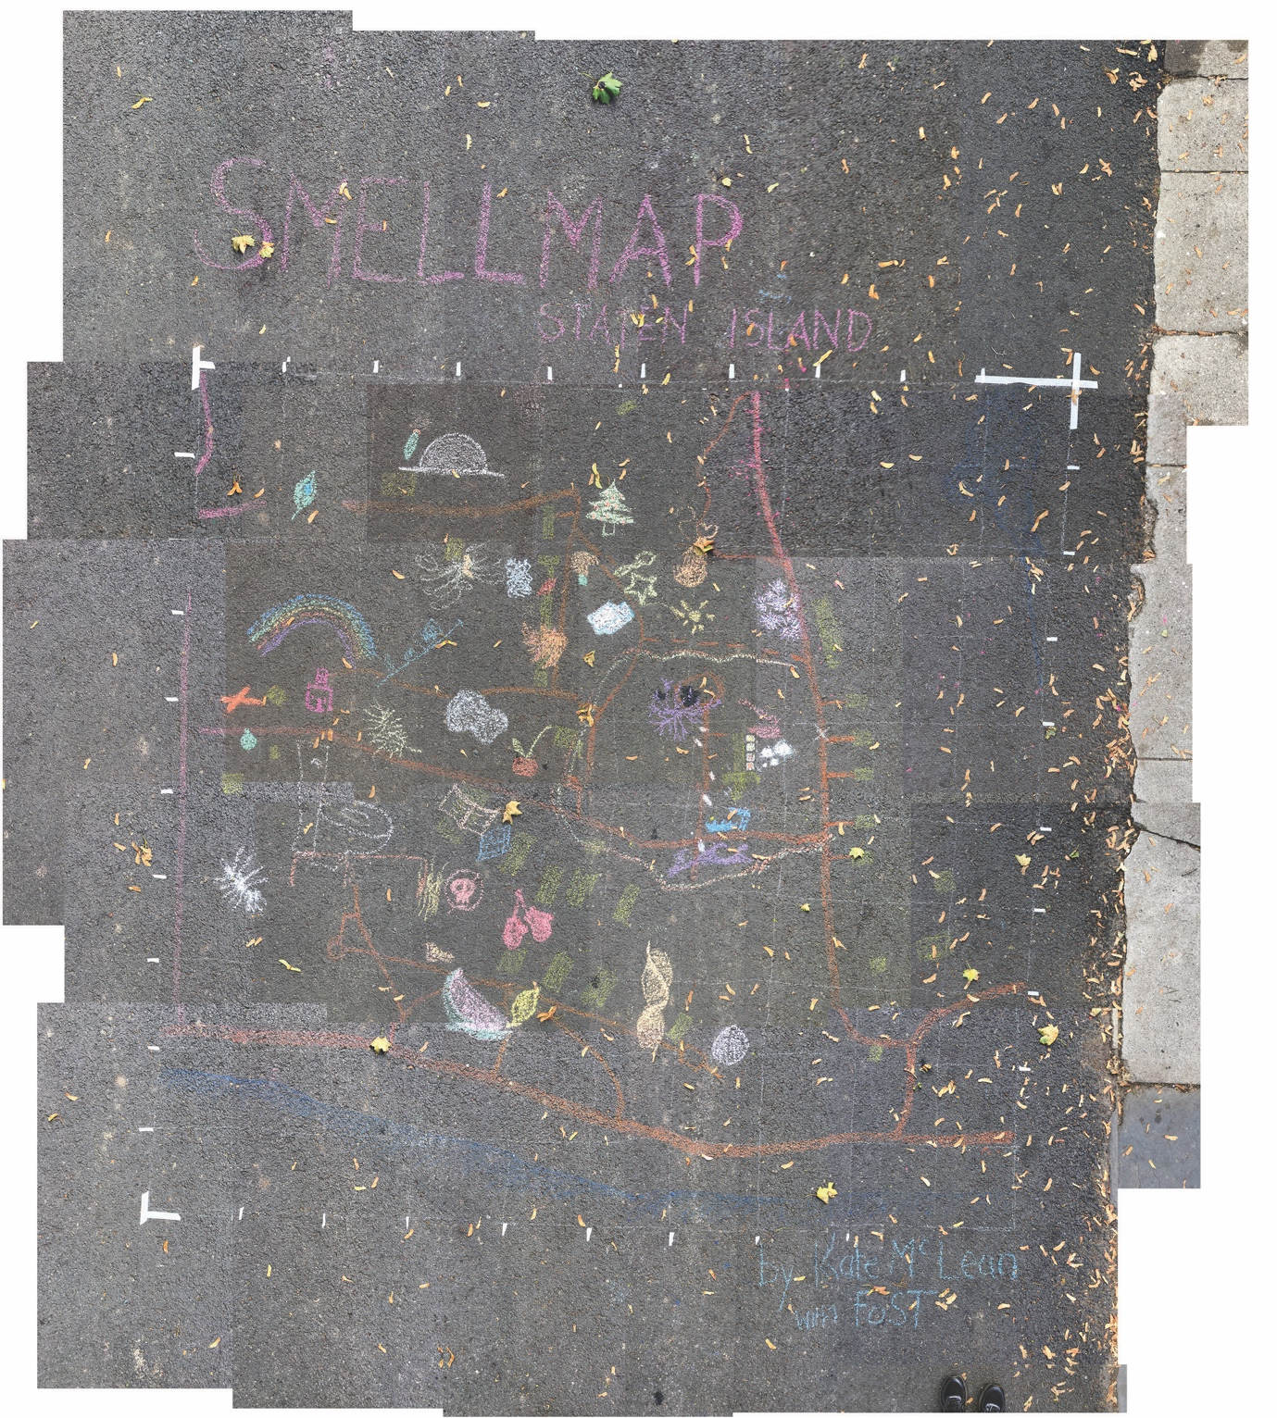

Figure 20.6: *Smellmap Staten Island*: end of Day 2, 2017. Photo credit: Kate McLean.

I planned for the map to dissolve following the first rains after the final day of FoST. I awoke on the final day of the event to an overcast sky and puddles on the sidewalks. I hurried to the site. The basemap remained, but every chalk drawing of a smell visual had disappeared. I had made a monumental mistake in not covering the work with a tarpaulin. The smells had all disappeared, exactly as anticipated, except a full 24 hours before the Staten Island smellmap was complete.

## Conclusion

The entire project was littered with additional micro-failures of time management, of leaves on the artwork, of distraction. As a designer, I assess what I would do differently next time to mitigate against such risks; as an artist I value how these made the project and the resulting stories surrounding its manifestation more poignant, intriguing, and memorable. Sensory communication design draws from both design and art’s relationships with failure; pragmatic organization and structuring (from design) and an openness to doubt and serendipity (from art).

As a hybrid of performance, design, and art, *Smellmap Staten Island* demonstrated that any newly discovered malfunction of human body during research requires sensitivity and background knowledge to signal supportive resources on the part of the researcher. A lack of existing canon for smell communication can be both liberating and intimidating for participants. When it comes to drawing personal smell perceptions we have no rules, we have never learned, we can only trust ourselves to interpret what we experience. An awareness of this means it is essential for the researcher to be supportive and to construct a framework for such an exploration.

This project was the first time I deployed a street art approach to the communication of smell, and while it is limited in the colour range, it has potential to uncover symbolic associative links that participants make, and the stories that emerge from communicating a smell. This is worthy of further research, and I can draw on this work to generate similar spontaneous and agile outdoor projects. Recording the intent behind the drawings was an oversight, and next time I would be sure to note these down at the time of their creation. The simultaneous joy and sadness I experienced when discovering an empty map on the morning of the final day of FoST manifested as a more enjoyable set of smellwalks with less pressure to complete the map and more time to engage fully with the participants.

Failure is important to the creative process, whether deliberate through an iterative design process or through being able to see the benefits that arise from errors. It is an essential part of a researcher’s reflexive journey.

## Bibliography

AbScent. ‘You’re Not Alone :: AbScent’, https://abscent.org/insights-blog/youre-not-alone.

Adams, Mags, and Kye Askins. ‘Sensewalking: Sensory Walking Methods for Social Scientists’, IAPS, 2008. http://www.iaps-association.org/sensewalking-sensory-walking-methods-for-social-scientists/.

Bacharach, Sondra. ‘Street Art and Consent’. *The British Journal of Aesthetics* 55.4 (1 October 2015): 481–95. https://doi.org/10.1093/aesthj/ayv030.

Design Council. ‘What Is the Framework for Innovation? Design Council’s Evolved Double Diamond’, Design Council, 17 March 2015. https://www.designcouncil.org.uk/news-opinion/what-framework-innovation-design-councils-evolved-double-diamond.

Engen, Trygg. *Odor Sensation and Memory*, New York: Greenwood Publishing Group, 1991.

Fifth Sense. ‘Other Causes’, *Fifth Sense* (blog). Accessed 26 June 2022. https://www.fifthsense.org.uk/other-causes/.

‘Future of StoryTelling | Reinventing the Way Stories Are Told’, https://futureofstorytelling.org/fest.

Gavin, Hector. *Sanitary Ramblings: Being Sketches and Illustrations of Bethnal Green*, Nabu Press, 2010.

Hoffman, Howard J., Shristi Rawal, Chuan-Ming Li, and Valerie B. Duffy. ‘New Chemosensory Component in the U.S. National Health and Nutrition Examination Survey (NHANES): First-Year Results for Measured Olfactory Dysfunction’, *Reviews in Endocrine & Metabolic Disorders* 17.2 (June 2016): 221–40. https://doi.org/10.1007/s11154-016-9364-1.

Kessels, Erik. *Failed It!: How to Turn Mistakes into Ideas and Other Advice for Successfully Screwing Up*. illustrated edition. London and New York, NY: Phaidon Press, 2016.

Kondo, Kenji, Shu Kikuta, Rumi Ueha, Keigo Suzukawa, and Tatsuya Yamasoba. ‘Age-Related Olfactory Dysfunction: Epidemiology, Pathophysiology, and Clinical Management’, *Frontiers in Aging Neuroscience* 12 (2020). https://www.frontiersin.org/article/10.3389/fnagi.2020.00208.

Majid, Asifa, Niclas Burenhult, Marcus Stensmyr, Josje de Valk, and Bill S. Hansson. ‘Olfactory Language and Abstraction across Cultures’, *Philosophical Transactions of the Royal Society B: Biological Sciences* 373.1752 (5 August 2018): 20170139. https://doi.org/10.1098/rstb.2017.0139.

‘Map Showing Location of Odor Producing Industries of New York and Brooklyn’, Charles F. Chandler Papers, circa 1870. Columbia University Rare Books and Manuscript Library.

Marketou, Jenny. *Smell It - A Do-It-Yourself Smell Map*, 2008, SAV (wallpaper) on Sintra Mount, 120 inches x 72 inches.

McLean, Kate. ‘Scentscape 06. 2015 – Singapore’. *Sensory Maps* (blog), https://sensorymaps.com/?projects=scentscape-06-2015-singapore.

———. ‘Smell Colour of a Brooklyn Block’, 12 September 2014, http://sensorymaps.blogspot.com/2014/09/smell-colour-of-brooklyn-block.html.

———. ‘Smellmap: Edinburgh | Sensory Maps’, Sensory Maps, 2011, http://sensorymaps.com/portfolio/smell-map-edinburgh/.

McLean, Katherine Jane. *Nose-First: Practices of Smellwalking and Smellscape Mapping’*, PhD diss., Royal College of Art, 2019. https://researchonline.rca.ac.uk/3945/.

NIDCD. ‘Smell Disorders’, NIDCD, https://www.nidcd.nih.gov/health/smell-disorders.

Norman, Donald A. *The Design of Everyday Things, Revised and Expanded Edition*, 2nd revised and expanded edition, Cambridge: MIT Press, 2013.

NYC Visitor Guide. ‘Snug Harbor Cultural Center & Botanical Garden’, *NYCgo*, https://www.nycgo.com/museums-galleries/snug-harbor-cultural-center-botanical-garden.

Rothbucher, Bernhard, and Katharina Rothbucher. ‘Failure in Design’, in Sebastian Kunert (ed), *Strategies in Failure Management: Scientific Insights, Case Studies and Tools*, pp. 267–85, Cham: Springer International Publishing, 2018. https://doi.org/10.1007/978-3-319-72757-8_18.

Schäfer, Laura, Valentin A. Schriever, and Ilona Croy. ‘Human Olfactory Dysfunction: Causes and Consequences’, *Cell and Tissue Research* 383.1 (1 January 2021): 569–79. https://doi.org/10.1007/s00441-020-03381-9.

Simon, Herbert A. ‘The Science of Design: Creating the Artificial’, *Design Issues* 4.1/2 (1988): 67–82. https://doi.org/10.2307/1511391.

1. Katherine Jane McLean*, Nose-First: Practices of Smellwalking and Smellscape Mapping’*, PhD diss., Royal College of Art, 2019. https://researchonline.rca.ac.uk/3945/.
2. Kate McLean, ‘Smellmap: Edinburgh | Sensory Maps’, *Sensory Maps*, 2011. http://sensorymaps.com/portfolio/smell-map-edinburgh/.
3. Chris Perkins and Kate McLean, ‘Smell walking and mapping’, in Sarah M. Hall and Helen Holmes (eds) *Mundane Methods*, Manchester: Manchester University Press, 2020, pp. 157–173. https://doi.org/10.1016/j.emospa.2022.100905
4. Trygg Engen, *Odor Sensation and Memory*, New York: Greenwood Publishing Group, 1991.
5. ‘Map Showing Location of Odor Producing Industries of New York and Brooklyn’, Charles F. Chandler Papers, circa 1870. Columbia University Rare Books and Manuscript Library; Jenny Marketou, *Smell It - A Do-It-Yourself Smell Map,* 2008, SAV (wallpaper) on Sintra Mount, 120 inches x 72 inches; Hector Gavin, *Sanitary Ramblings: Being Sketches and Illustrations of Bethnal Green*, Nabu Press, 2010.
6. Bernhard Rothbucher, and Katharina Rothbucher, ‘Failure in Design’, in Sebastian Kunert (ed) *Strategies in Failure Management: Scientific Insights, Case Studies and Tools*, Cham: Springer International Publishing, 2018, pp. 267–85. https://doi.org/10.1007/978-3-319-72757-8_18.
7. Herbert A. Simon, ‘The Science of Design: Creating the Artificial’, *Design Issues* 4.1/2 (1988): 67–82. https://doi.org/10.2307/1511391.
8. Design Council, ‘What Is the Framework for Innovation? Design Council’s Evolved Double Diamond’, Design Council, 17 March 2015, https://www.designcouncil.org.uk/news-opinion/what-framework-innovation-design-councils-evolved-double-diamond.
9. The Interaction Design Foundation, ‘Design Failures’, https://www.interaction-design.org/literature/article/design-failures
10. Donald A. Norman, *The Design of Everyday Things, Revised and Expanded Edition,* 2nd revised and expanded ed, Cambridge: MIT Press, 2013, 64.
11. Erik Kessels, *Failed It!: How to Turn Mistakes into Ideas and Other Advice for Successfully Screwing Up,* Illustrated edition, London and New York, NY: Phaidon Press, 2016, 43.
12. ‘Future of StoryTelling | Reinventing the Way Stories Are Told’, https://futureofstorytelling.org/fest.
13. NYC NYC Visitor Guide, ‘Snug Harbor Cultural Center & Botanical Garden’, *NYC Go*, https://www.nycgo.com/museums-galleries/snug-harbor-cultural-center-botanical-garden
14. Mags Adams, and Kye Askins, ‘Sensewalking: Sensory Walking Methods for Social Scientists’, IAPS, 2008. http://www.iaps-association.org/sensewalking-sensory-walking-methods-for-social-scientists/
15. McLean, ‘Nose-First’, 90.
16. Laura, Schäfer, Valentin A. Schriever, and Ilona Croy, ‘Human Olfactory Dysfunction: Causes and Consequences’, *Cell and Tissue Research* 383.1 (1 January 2021): 569–79. https://doi.org/10.1007/s00441-020-03381-9.
17. Kenji Kondo, Shu Kikuta, Rumi Ueha, Keigo Suzukawa, and Tatsuya Yamasoba, ‘Age-Related Olfactory Dysfunction: Epidemiology, Pathophysiology, and Clinical Management’, *Frontiers in Aging Neuroscience* 12 (2020). https://www.frontiersin.org/article/10.3389/fnagi.2020.00208.
18. Asifa Majid, Nicolas Burenhult, Marcus Stensmyr, Josje de Valk, and Bill S. Hansson, ‘Olfactory Language and Abstraction Across Cultures’, *Philosophical Transactions of the Royal Society B: Biological Sciences* 373.1752 (5 August 2018): 20170139. https://doi.org/10.1098/rstb.2017.0139.
19. Kate McLean, ‘Smell Colour of a Brooklyn Block’, 12 September 2014, http://sensorymaps.blogspot.com/2014/09/smell-colour-of-brooklyn-block.html.
20. Kate McLean, ‘Scentscape 06. 2015 – Singapore’, *Sensory Maps* (blog), https://sensorymaps.com/?projects=scentscape-06-2015-singapore.
21. NIDCD, ‘Smell Disorders’, NIDCD, https://www.nidcd.nih.gov/health/smell-disorders.
22. Howard J. Hoffman, Shristi Rawal, Chuan-Ming Li, and Valerie B. Duffy, ‘New Chemosensory Component in the U.S. National Health and Nutrition Examination Survey (NHANES): First-Year Results for Measured Olfactory Dysfunction’, *Reviews in Endocrine & Metabolic Disorders* 17.2 (June 2016): 221–40. https://doi.org/10.1007/s11154-016-9364-1.
23. Fifth Sense, ‘Other Causes’, *Fifth Sense* (blog), https://www.fifthsense.org.uk/other-causes/.
24. AbScent, ‘You’re Not Alone :: AbScent’, https://abscent.org/insights-blog/youre-not-alone.
25. Sondra Bacharach, ‘Street Art and Consent’, *The British Journal of Aesthetics* 55.4 (1 October 2015): 481–95. https://doi.org/10.1093/aesthj/ayv030.
26.